Exercise 3: Azure Blueprints

Scenario

Learning how to create and assign blueprints enables the definition of common patterns to develop reusable and rapidly deployable configurations based on Resource Manager templates, policy, security, and more. In this tutorial, you learn to use Azure Blueprints to do some of the common tasks related to creating, publishing, and assigning a blueprint within your organization, such as:

* + Create a new blueprint and add various supported artifacts
  + Make changes to an existing blueprint still in Draft
  + Mark a blueprint as ready to assign with Published
  + Assign a blueprint to an existing subscription
  + Check the status and progress of an assigned blueprint
  + Remove a blueprint that has been assigned to a subscription

Create a blueprint

The first step in defining a standard pattern for compliance is to compose a blueprint from the available resources. In this example, create a new blueprint named 'Contoso-IT' to configure role and policy assignments for the subscription, add a new resource group, and create a Resource Manager template and role assignment on the new resource group.

* + Click on **All services** and searching for and selecting **Policy** in the left pane. On the Policy page, click on **Blueprints**.
  + Select **Blueprint Definitions** from the page on the left and click the **+ Create Blueprint** button at the top of the page.
  + Alternately, click on **Create** from the **Getting started** page to go straight to creating a blueprint.

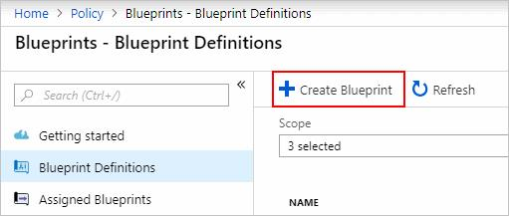

* + Name the Blueprint **Contoso**, but leave Blueprint **Description** blank for now. In the **Definition Location** box, click the ellipsis on the right, select the management group **Contoso** and click **Select**.

Blueprint definitions can only be saved to management groups.

* 1. Verify the information is correct (the **Blueprint Name** and **Definition Location** fields can't be changed later) and click **Next : Artifacts** at the bottom of the page or the **Artifacts** tab at the top of the page.
  2. Add role assignment at subscription: Left-click on the **+ Add artifact…** row under **Subscription** and the 'Add artifact' window opens on the right side of the browser. Select 'Role Assignment' for *Artifact type*. Under *Role*, select 'Contributor' and leave the *Add User, App or Group* field with the checkbox indicating a **dynamic parameter**. Click **Add** to add this artifact to the blueprint.

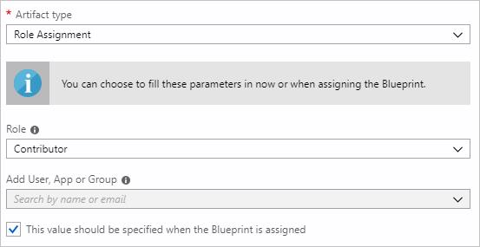

* 1. Add policy assignment at subscription: Left-click on the **+ Add artifact…** row directly under the **Subscription**. Select 'Policy Assignment' for *Artifact type*. Change *Type* to 'Built-in' and in *Search* enter 'tag'. Click out of *Search* for the filtering to occur. Select ‘**Append tag and its default value to resource groups**' by clicking on it. Click **Add** to add this artifact to the blueprint.
  2. Click on the row of policy assignment 'Apply tag and its default value to resource groups'. The windo w to provide parameters to the artifact as part of the blueprint definition opens and allows setting the parameters for all assignments (**static parameters**) based on this blueprint instead of during assignment (**dynamic parameters**). This example uses dynamic parameters during blueprint assignment, so leave the defaults and click **Cancel**.
  3. Add resource group at subscription: Left-click on the **+ Add artifact…** row under **Subscription**. Select 'Resource Group' for *Artifact type*. Leave the *Resource Group Name* and *Location* fields blank, but make sure that the checkbox is checked on each property to make them **dynamic parameters**. Click **Add** to add this artifact to the blueprint.
  4. Add template under resource group: Left-click on the **+ Add artifact..** row directly under the ResourceGroup entry. Select 'Azure Resource Manager template' for *Artifact type*, set Artifact display name to 'StorageAccount', and leave *Description* blank.
  5. On the **Template** tab in the editor box, paste the following Resource Manager template.

{  
 "$schema": "[https://schema.management.azure.com/schemas/2015-01-01/deploymentTemplate.json#](https://schema.management.azure.com/schemas/2015-01-01/deploymentTemplate.json)",  
 "contentVersion": "1.0.0.0",  
 "parameters": {  
 "storageAccountType": {  
 "type": "string",  
 "defaultValue": "Standard_LRS",  
 "allowedValues": [  
 "Standard_LRS",  
 "Standard_GRS",  
 "Standard_ZRS",  
 "Premium_LRS"  
 ],  
 "metadata": {  
 "description": "Storage Account type"  
 }  
 }  
 },  
 "variables": {  
 "storageAccountName": "[concat(uniquestring(resourceGroup().id), 'standardsa')]"  
 },  
 "resources": [{  
 "type": "Microsoft.Storage/storageAccounts",  
 "name": "[variables('storageAccountName')]",  
 "apiVersion": "2016-01-01",  
 "location": "[resourceGroup().location]",  
 "sku": {  
 "name": "[parameters('storageAccountType')]"  
 },  
 "kind": "Storage",  
 "properties": {}  
 }],  
 "outputs": {  
 "storageAccountName": {  
 "type": "string",  
 "value": "[variables('storageAccountName')]"  
 }  
 }  
}

* 1. After pasting the template, click on the **Parameters** tab and note that the template parameter **storageAccountType** and default value **Standard_LRS** was automatically detected and populated, but configured as a **dynamic parameter**.
  2. Remove the check from the checkbox and note that the drop-down only contains values included in the Resource Manager template under **allowedValues**.
  3. Check the box to set it back to a **dynamic parameter**. Click **Add** to add this artifact to the blueprint.

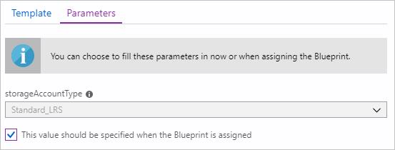

* 1. Your completed blueprint should look similar to the following. Notice that each artifact has 'x out of y parameters populated' under the Parameters column. The **dynamic parameters** are set during each assignment of the blueprint.

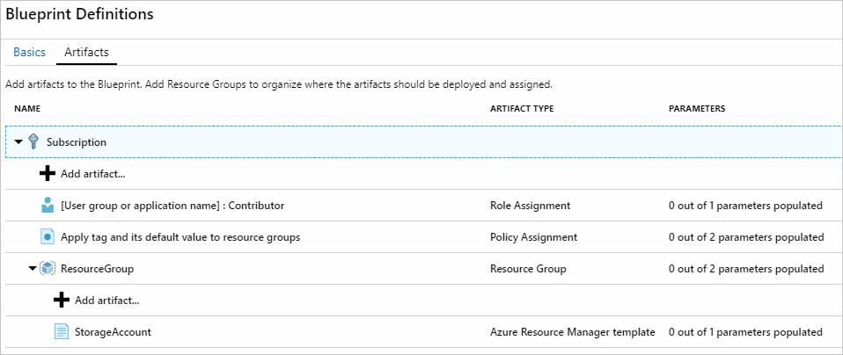

* 1. Now that all planned artifacts have been added, click **Save Draft** at the bottom of the page.

Edit a blueprint

In the previous Blueprint, a Description wasn't provided, nor the role assignment added to the new resource group. Both can be fixed by following these steps:

* 1. Select **Blueprint Definitions** from the page on the left.
  2. In the list of blueprints, right-click on the one you previously created and select **Edit Blueprint**.
  3. In the **Blueprint Description**, provide some information about the blueprint and the artifacts that compose it. In this case, enter something like: "This blueprint sets tag policy and role assignment on the subscription, creates a ResourceGroup, and deploys a resource template and role assignment to that ResourceGroup."
  4. Click **Next : Artifacts** at the bottom of the page or the **Artifacts** tab at the top of the page.
  5. Add role assignment under resource group: Left-click on the **+ Add artifact…** row directly under the **ResourceGroup** entry. Select 'Role Assignment' for *Artifact type*. Under *Role*, select '*Owner*' and remove the check for the *Add User, App or Group* field and search for and select a user, app, or group to add. This artifact uses a **static parameter** set the same in every assignment of this blueprint. Click **Add** to add this artifact to the blueprint.

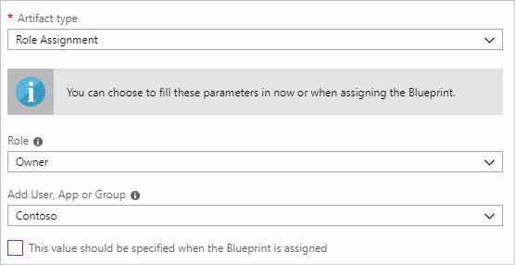

* 1. Your completed blueprint should look similar to the following. Notice that the newly added role assignment shows 1 out of 1 parameters populated meaning that it's a static parameter.

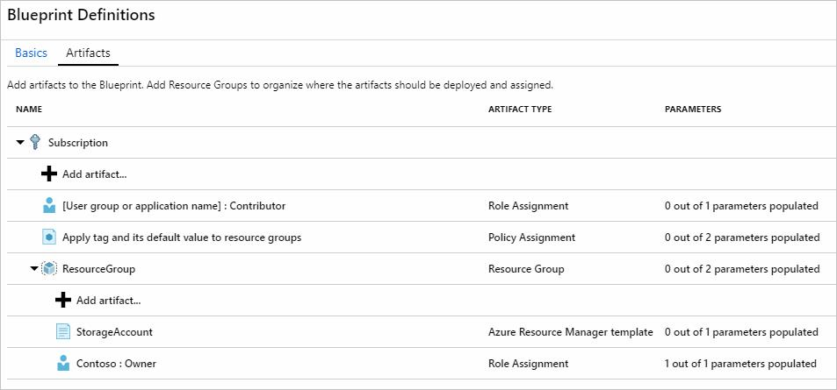

* 1. Click **Save Draft** now that it has been updated.

Publish a blueprint

Now that all the planned artifacts have been added to the blueprint, it's time to publish it. Publishing makes it available to be assigned to a subscription.

* 1. Select **Blueprint Definitions** from the page on the left.
  2. In the list of blueprints, right-click on the one you previously created and select **Publish Blueprint**.
  3. On the dialog that opens, provide a Version (letters, numbers, and hyphens with a max length of 20 characters) such as 'v1' and Change notes (optional) such as 'First publish'.
  4. Click** Publish** at the bottom of the page.

Assign a blueprint

Once a blueprint has been published, it can be assigned to a subscription. Assign the blueprint you created to one of the subscriptions in your management group hierarchy.

* 1. Select **Blueprint Definitions** from the page on the left.
  2. In the list of blueprints, right-click on the one you previously created (or left-click on the ellipsis) and select **Assign Blueprint**.
  3. On the **Assign Blueprint** page, select the subscription(s) you want to deploy this blueprint to from the **Subscription** drop-down.

**Note:** An assignment is created for each subscription that is selected allowing changes to a single subscription assignment at a later time without forcing changes on the remainder of the selected subscriptions.

* 1. For **Assigned Name**, provide a unique name for this assignment.
  2. In **Location**, select a region for the managed identity to be created in. Azure Blueprint uses this managed identity to deploy all artifacts in the assigned blueprint.
  3. Leave the **Blueprint definition version** drop-down of **Published** versions on the 'v1' entry (default as the most recently Published version).
  4. For **Lock Assignment**, leave the default of **Don't Lock**.
  5. For the subscription level role assignment **[User group or application name] : Contributor**, search for and select a user, app, or group.
  6. For the subscription level policy assignment, set the **Tag Name** to 'CostCenter' and the **Tag Value**to 'ContosoIT'.
  7. For the 'ResourceGroup', provide a **Name** of 'StorageAccount' and a **Location** of 'East US 2' from the drop-down.
  8. On the Azure Resource Manager template 'StorageAccount', select 'Standard_GRS' for the **storageAccountType** parameter.
  9. Read the information box at the bottom of the page and then click **Assign**.

Track deployment of a blueprint

When a blueprint has been assigned to one or more subscriptions, two things happen:

* + The blueprint is added to the Assigned Blueprints page per subscription assigned to
  + The process of deploying all the artifacts defined by the blueprint begins

Now that the blueprint has been assigned to a subscription, verify progress of the deployment.

* + Select Assigned Blueprints from the page on the left.
  + In the list of blueprints, right-click on the one you previously assigned and select View Assignment Details.

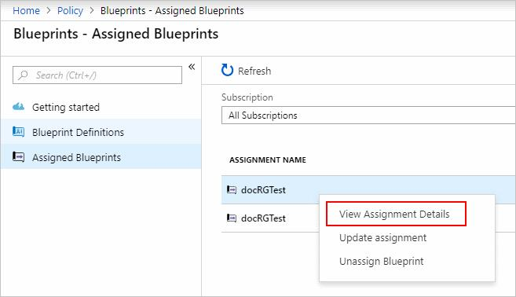

* + On the Deployment Details page, validate that all artifacts have been successfully deployed and that there have been no errors during the deployment. If errors occurred, see [troubleshooting blueprint](https://labondemand.com/content/lab51772/If%20errors%20occurred,%20see%20troubleshooting%20blueprint%20for%20steps%20to%20determine%20what%20went%20wrong.)for steps to determine what went wrong.

Unassign a blueprint

If no longer needed, remove a blueprint assignment from a subscription. The blueprint may have been replaced by a newer blueprint with updated patterns, policies, and designs. When a blueprint is removed, the artifacts assigned as part of that blueprint are left behind.

* 1. Select **Assigned Blueprints** from the page on the left.
  2. In the list of blueprints, select the blueprint that is to be unassigned and then click the Unassign Blueprint button at the top of the page.
  3. Read the confirmation message and then click **OK**.

Review [Understand the life-cycle of an Azure Blueprint](https://docs.microsoft.com/en-us/azure/governance/blueprints/concepts/lifecycle) as it is an essential aspect of Blueprints.

PreviousNext: Exercise 4: Resource Graph